**MODULE 3 - EXECUTIVE SUMMARY REPORT**

ALY6050 - Introduction to Enterprise Analytics

Instructed by Prof. Dr. Roy Wada

Vidhya Lakshmi Vaithilingam Palanimurugan

May 2, 2022

**INTRODUCTION**

Financial time series forecasting is a top choice of computational intelligence for finance researchers in both academia and industry. It has extensive application areas and significant influence. Various methods and techniques are used to financial forecasting in different industries. This project experiments with few short-term and long-term methods as well automating the forecasting using R programming. The techniques used in this project are Exponential Smoothing, Moving Average, ARIMA and Auto ARIMA.

**SHORT-TERM FORECASTING OF STOCKS**

**Analyzing the given stocks data:**

The given external dataset is the collection of the closing prices of the Stocks and their volume. The stock prices of the companies Coca-Cola (NYSE:KO) and Costco Wholesale (NASDAQ:COST) are listed for a period of 252 trading days from Jan 27, 2021 to Jan 25, 2022. The figure 1 and 2 illustrated the trend of closing prices of these company stocks in the given time.

*Figure 1: Closing Price Trend of Coco-cola shares*

The stock price of Costco was $356.39 on Jan 27, 2021, and $477.32 on Jan 25, 2022. For the same time-period, the stock prices of Coco-cola were $48.53 and $59.82 respectively. We can see that the stock price of both the stocks have increased on their 252nd period compared to their 1st period. We can say that they seem to have an increasing trend and we cannot conclude further without enough evidence.

*Figure 2: Closing Price Trend of Costco shares*

**Forecasting stock price using Exponential smoothing:**

Exponential smoothing is a time series forecasting method mainly used for the univariate data. Single Exponential Smoothing (SES) is used here considering that the given data doesn’t have trend or seasonality. This requires a single parameter, called alpha (**α**), also called the **smoothing factor** or smoothing coefficient. The value of alpha lies between 0 and 1 excluding them.

Here, we forecast the stock prices with four different alpha values (smoothing factor) namely 0.15, 0.35, 0.55 and 0.75 for both the companies. We can observe from Table 1 that the predicted value decreases with the increase in the value of the alpha. Say, the forecasted value of Costco is $502.41 and $479.81 when alpha is 0.15 and 0.75 respectively. To choose the best smoothing factor, we compute the Mean Absolute Percentage Deviation (MAPD). The summary of these values is listed in Table 1. We should select the forecast value based on the lowest MAPD value. From Table 1 we can conclude that when **alpha is 0.75**, Costco and Coco-cola stocks have a the MAPD of 1.02% and 0.68% respectively which is lowest of all others. Hence the predicted 253rd value of stocks of COST and KO using this method is **$479.81** and **$59.89** respectively.

*Table 1: Forecasting Stock Price for the 253rd period using Exponential Smoothing*

|  |  |  |  |  |
| --- | --- | --- | --- | --- |
| **Smoothing parameter**  **α** | **COST** | | **KO** | |
| **Forecasted Price**  **(in $)** | **MAPD** | **Forecasted Price**  **(in $)** | **MAPD** |
| 0.15 | 502.41 | 2.26% | 60.29 | 1.32% |
| 0.35 | 485.40 | 1.38% | 60.23 | 0.84% |
| 0.55 | 481.62 | 1.12% | 60.02 | 0.72% |
| 0.75 | 479.81 | 1.02% | 59.89 | 0.68% |

**Forecasting stock price using Adjusted Exponential Smoothing:**

Exponential smoothing in general is based on the weighted sum of the previous observations, but the model clearly uses an exponentially decreasing weight for previous observations. The trend adjusted exponential smoothing is one other variation of exponential smoothing used for forecasting. In this case, we initially estimate of the forecasted value using exponential smoothing by selecting a smoothing factor. Then we choose a trend parameter (beta value) and calculate the trend based on beta value, forecasted value from exponential smoothing and previous calculated trend value. The final predicated or forecasted value (AFt) in this method is the sum of Forecasted valued from the exponential smoothing (Ft) and Trend value (Tt).

*Table 2: Forecasting Stock Price for the 253rd period using Adjusted Exponential Smoothing*

|  |  |  |  |  |
| --- | --- | --- | --- | --- |
| **Trend parameter**  **β** | **COST** | | **KO** | |
| **Forecasted Price**  **(in $)** | **MAPE** | **Forecasted Price**  **(in $)** | **MAPE** |
| 0.15 | 477.331 | 1.00% | 59.964 | 0.70% |
| 0.25 | 477.507 | 0.98% | 59.873 | 0.70% |
| 0.45 | 478.289 | 0.96% | 59.782 | 0.69% |
| 0.85 | 477.384 | 0.95% | 59.760 | 0.68% |

Here, we forecast the stock prices with smoothing factor and trend value. We set the smoothing factor (alpha) value as 0.55 and have four different trend values namely 0.15, 0.25, 0.45 and 0.85 for both the companies. We can observe from Table 2 that the predicted values various based on the trend parameter. Say, the forecasted value of Costco and Coco-cola is **$477.384 and $59.760** respectively when **alpha is 0.55 and beta value is 0.85**. To choose the best trend, we compute the Mean Absolute Percentage Error (MAPE). The summary of these values is listed in Table 2. We should select the forecast value based on the lowest error value. From Table 2, we can conclude that with a smoothing factor, alpha is 0.55, when trend parameter beta is 0.85, Costco and Coco-cola stocks have the lowest error percentage of 0.95% and 0.68% respectively which is lowest of all others. Hence the predicted 253rd value of stocks of COST and KO using this method is **$477.384 and $59.760** respectively.

**LONG-TERM FORECASTING OF STOCKS**

*Figure 3: Long-term Stock Price forecast for Costco shares*

A Weighted Moving Average puts more weight on latest data and less on earlier data. In a 3-period weighted moving average, the fourth period is the weighted average of the first three periods. For the first 100 period of the given data, we use this method to forecast the values. The weights used are 0.5 (for the most recent period), 0.3 (for the period before the most recent), and 0.2 (for two periods ago). For periods 101 through 257, the linear trend is used to forecast the values of the stocks.

*Figure 4: Long-term Stock Price forecast for KO shares*

Figures 3 and 4 illustrate the long-term predictions of the stock prices of Costco and Coco-cola respectively. From the figures and Table 3, we can infer that the stock prices of Costco (COST) are higher than its actual price. On the other hand, the forecasted prices of the Coco-cola (KO) are lesser than its actual price. To conclude, **the forecasted prices of both the stocks using this weighed moving average 3 doesn’t yield accurate results.** The prices of COST were overvalued while the prices of KO were undermined.

*Table 3: Forecasting Long-term Stock Prices using Trend*

|  |  |  |  |  |  |
| --- | --- | --- | --- | --- | --- |
| **Date** | **Period** | **COST Actual Price**  **(in $)** | **COST Forecasted Price (in $)** | **KO Actual Price**  **(in $)** | **KO Forecasted Price (in $)** |
| 1/26/2022 | 253 | 483.47 | 555.40 | 59.6 | 57.95 |
| 1/27/2022 | 254 | 482.52 | 556.44 | 59.65 | 57.97 |
| 1/28/2022 | 255 | 492.43 | 557.48 | 60.84 | 57.99 |
| 1/29/2022 | 256 | NA (weekend) | 558.52 | NA (weekend) | 58.02 |
| 1/30/2022 | 257 | NA (weekend) | 559.56 | NA (weekend) | 58.04 |

Mean Absolute Percent Error refers to persistent forecast error i.e., consistent under-forecasting or over-forecasting. The error percentage is the average of individual error value given by absolute difference of Actual and Forecasted value over Actual value. We take absolute values as the magnitude of the error is more important than the direction of the error. The MAPE of Costco and Coco-cola stocks using the weighted moving average three method is **2.38%** and **1.89%** respectively.

Comparing these results of predicted stock prices of Costco and Coco-cola with the prices obtained from exponential smoothing methods, we can conclude that the **KO stock prices** were more accurate to the actual prices when **Adjusted Exponential smoothing was used**. For the **COST stocks**, the predicted prices from **all three methods** **were insignificant** to the actual prices of the stocks.

**TIME-SERIES ANALYSIS OF STOCKS USING R**

The stock prices or any financial data is generally huge and hence using R programming helps to analyze them more efficiently and dynamically. The last five years data (source: yahoo finance) of Costco and Coco-cola’s stock prices are illustrated in figures 5 and 6.

*Figure 5: Last five years data of COSTCO shares*

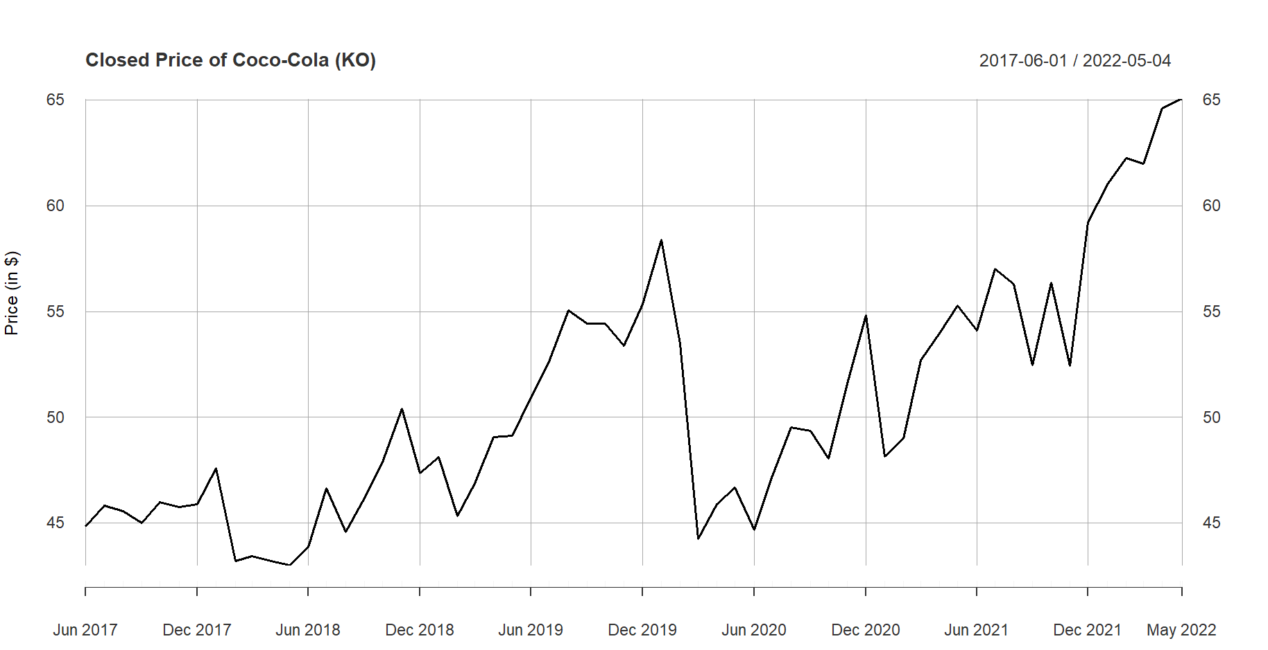

*Figure 6: Last five years data of Coco-Cola shares*

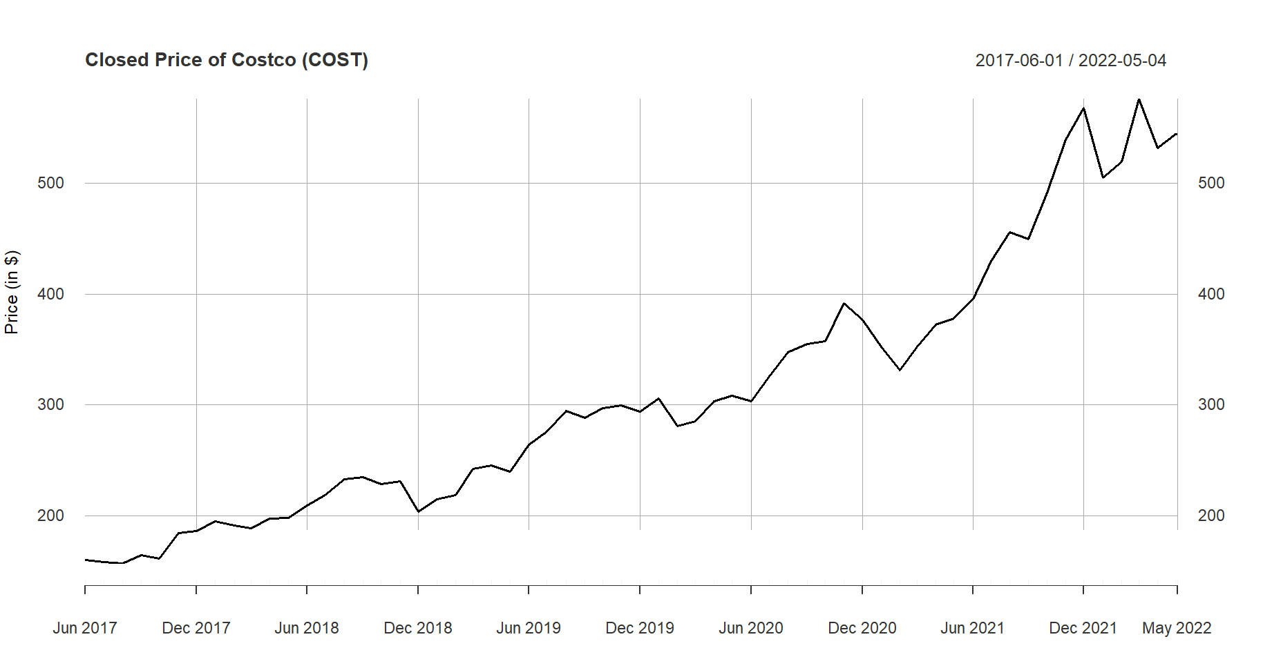

**Forecasting using ARIMA(1)**

Auto Regressive Integrated Moving Average (ARIMA) is a model to measure occurrences that happen over a period. It uses the past data to predict the future values in the series.

*Figure 7: Forecasting Coco-Cola shares using ARIMA(1)*

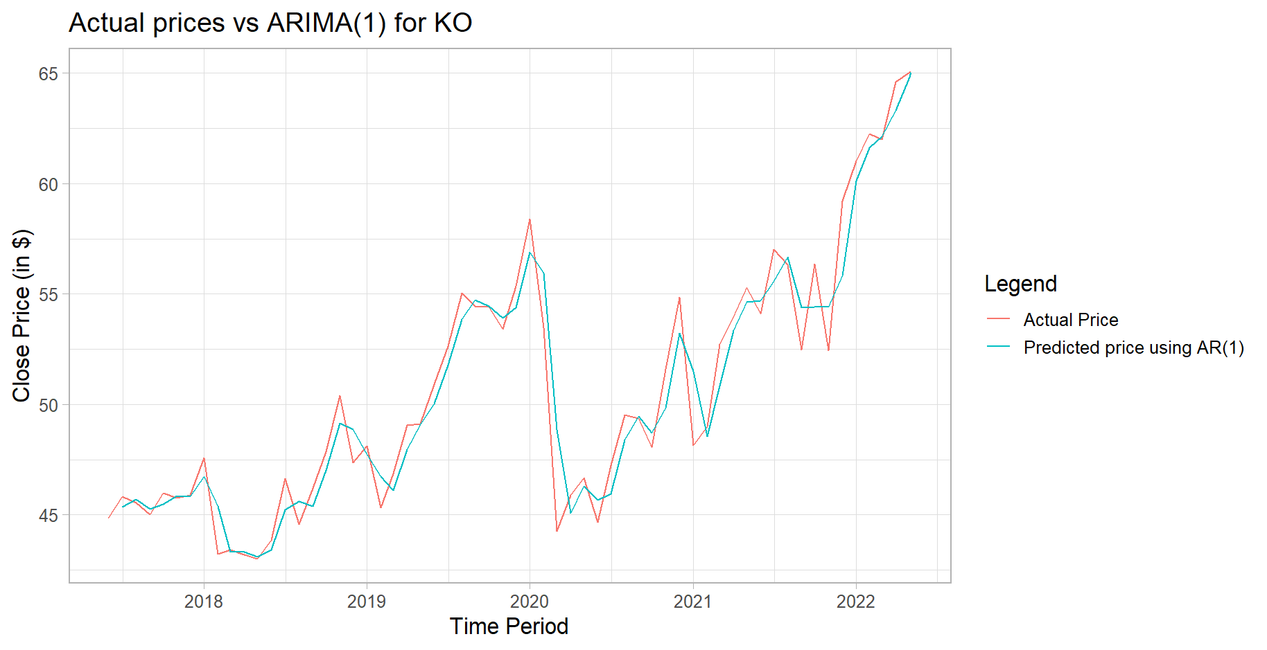

*Figure 8: Forecasting Costco shares using ARIMA(1)*

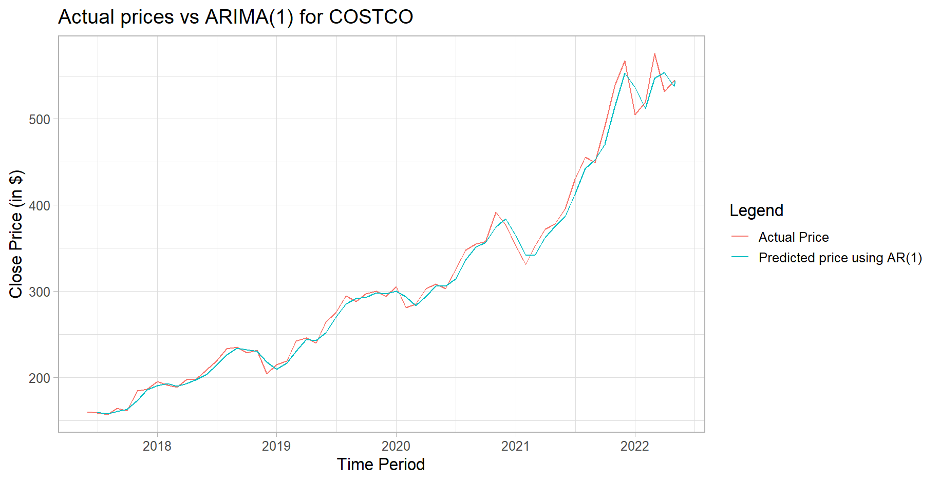

Figures 7 and 8 illustrate the predicted price of the KO and COST stocks using ARIMA(1). Since the predicted value for a given point is the average of the previous values, we can see the predicted line in the graph is very closer to the actual price.

**Forecasting using Exponential Smoothing (long-term)**

Figures 9 and 10 illustrates the long-term forecasting of the Coco-cola and Costco shares respectively using the Single Exponential Smoothing. The forecast is made for the next 2 years with a confidence level (85% and 95%) and the smoothing factor (**alpha**) as **0.55**. The **dark blue area** in the prediction contains the **85% confidence** interval values while the outer **light blue area** contains the **95%** confidence interval values of the stock prices.

*Figure 9: Long-term Forecasting of Coco-cola shares using Exponential Smoothing*

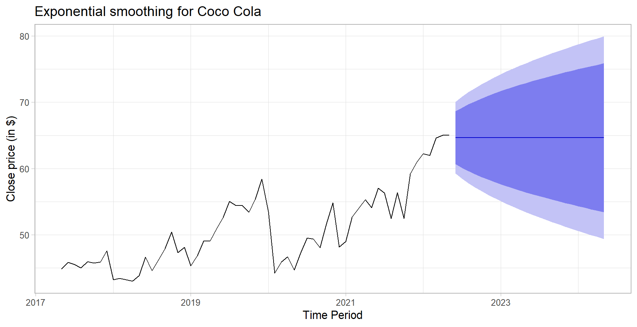

*Figure 10: Long-term Forecasting of Costco shares using Exponential Smoothing*

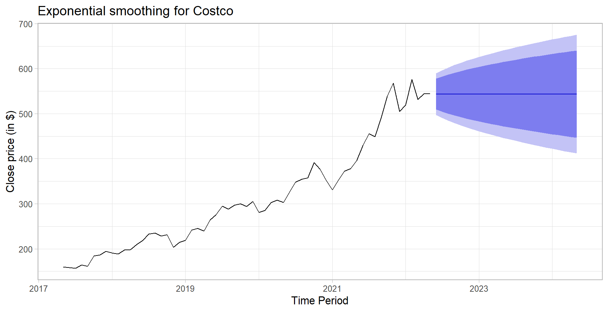

In this method, along with smoothing factor, we use the confidence intervals to predict the value of the stock price. With 95% confidence level, we conclude that actual prices of these stocks would fall in the confidence interval of their predicted values.

**Forecasting using Auto-ARIMA (long-term)**

R language has the function “**auto.arima”** which returns the best ARIMA model according to either AIC, AICc or BIC value. It directs a search over possible model within the order constraints provided.

*Figure 11: Long-term Forecasting of Coco-Cola (KO) shares using Auto-ARIMA*

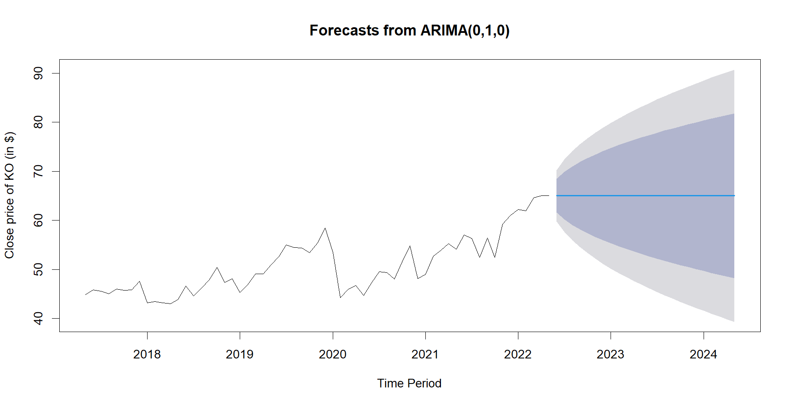

Figure 11 is the result from auto.arima performed for the Coco-Cola (**KO**) stock prices. The model chosen by the function to forecast the KO stock prices **is ARIMA(0,1,0)** otherwise called as AR(1) model. The auto.arima performed for the Costco (**COST**) stock prices is shown in figure 12. The model chosen by the function to forecast the COST stock prices is **ARIMA(0,1,0)(0,0,1)[12].** ARIMA(0,0,1) means the following:

* p = 0 (The trend component of the time series is not playing a significant role)
* d = 0 (The time series provided is stationary and does not require differencing)
* q = 1 (The time series has a randomness component and the ACF after the lag 2 becomes 0)

*Figure 12: Long-term Forecasting of Costco (COST) shares using Auto-ARIMA*

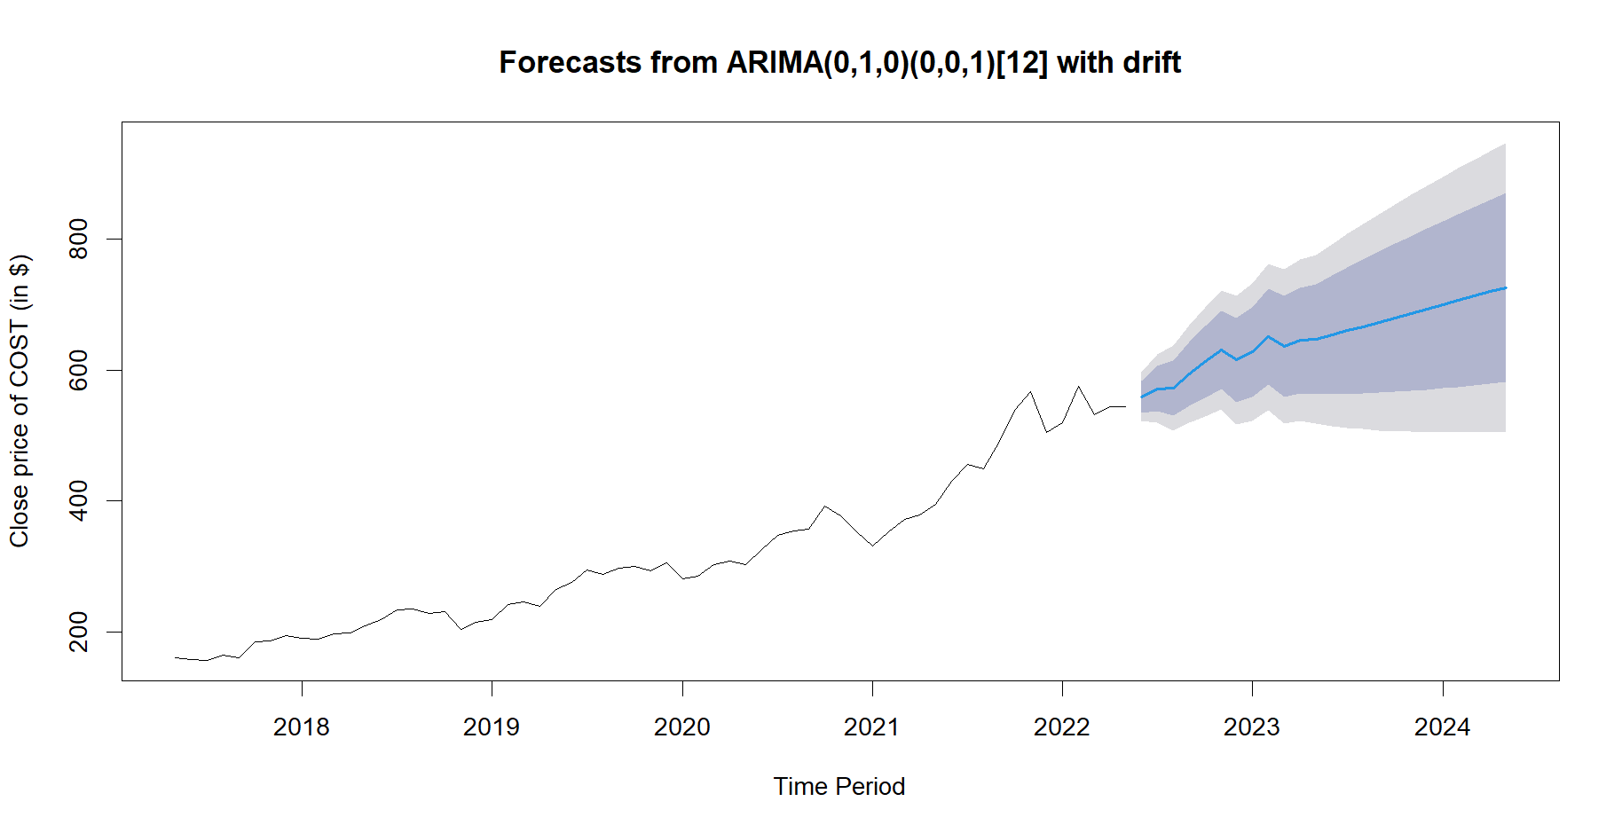

**Forecasting using Auto-ARIMA (long-term) - Wine Dataset**

*Figure 13: Long-term Forecasting of Wine prices using Auto-ARIMA*

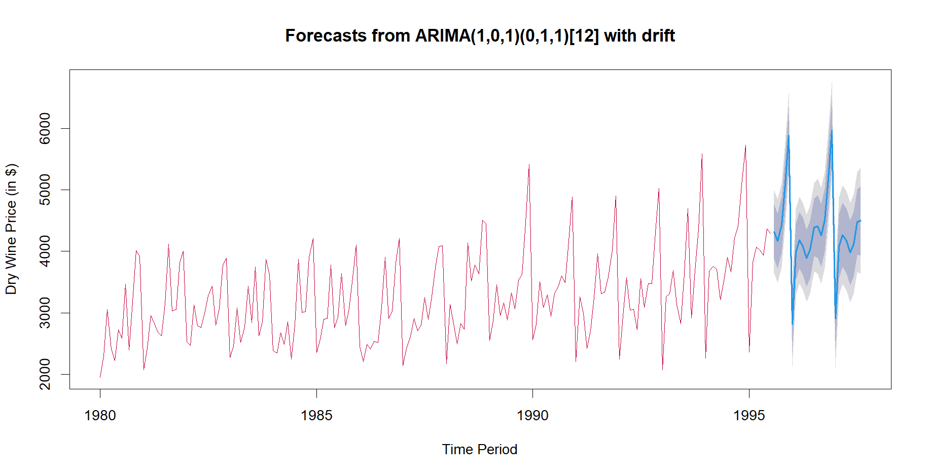

Figure 13 shows the forecasted price of Dry Wine for the period 1995 to 1998. The data contains the prices of dry wine from 1980 to 1995 and the graph shows that there is a similar trend in its pricing. We can also observe that the price of the wine keeps fluctuating up and down every year with a highest peak value and lowest peak value. Based on this trend the auto-arima function forecasts the best possible prices for following years as shown is the blue line and highlighted in grey colour.

**CONCLUSION**

From the above analysis, we see that the forecasted prices of the stock are more accurate in **exponential smoothing** than the moving average forecast prices. On analysing **COSTCO** (COST) stock prices and obtaining forecasted values, we can conclude that **exponential smoothing with alpha 0.55** gives the most accurate value for its stock prices. Auto-arima for COSTCO predicts an increasing trend of its stock prices which may reach above **$800 in 2024.** On the other hand, analysis, and predictions of the Coco-Cola (KO) stock price shows that predicted value from adjusted exponential smoothing with alpha 0.55 and trend parameter 0.85 is the closest to the actual price. Auto-arimafor **KO** uses ARIMA(0,1,0) and predicts the stock prices would range from **$40-$80.** And finally, from the analysis and auto-arima forecasted values for dry wine prices, we can infer that the wine prices follows a trend and the prediction model detects and uses that trend to forecast the future prices.

**REFERENCES**

Evans, J. R. (2013). *Statistics, Data Analysis, and Decision Modeling* (5th Ed). Pearson

**APPENDIX**

* ALY6050_MOD3Project_VaithilingamPalanimuruganV.R
* ALY6050_MOD3Project_VaithilingamPalanimuruganV.xlsx